ЛАБОРАТОРНА РОБОТА № 7
Адаптивна верстка. Робота з трансформаціями.
Мета: Навчитися створювати адаптивні веб-сторінки
Хід роботи:
Завдання 1: Реалізувати сторінку за даним шаблоном, використовуючи довільні зображення та довільний контент:
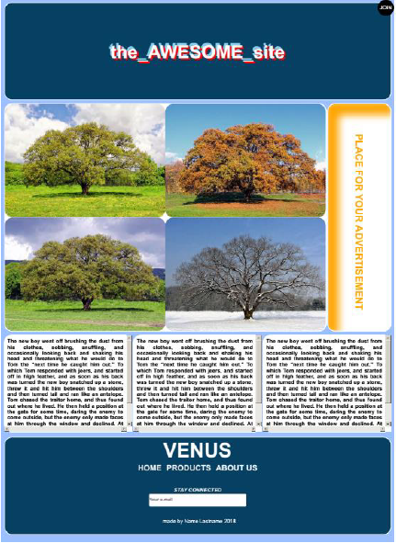

Лістинг програми:
HTML

<!DOCTYPE html>
<html lang="en">
<head>
<meta charset="UTF-8">
<title>task_1</title>
<link rel="stylesheet" href="1.css">
</head>
<body>
<div>
<div id="ramkatop">
<h6>AWESOME</h6>
</div>
<div id="fotki">
<div id="photo1">
<div class="display" >
<div class="photo"></div>
<div class="photo"></div>
<div class="photo"></div>
<div class="photo"></div>
</div>
</div>
<div id="bichnapanel"><p><b>PLACE FOT YOUR ADVERTISEMENT</b></p></div>
</div>
<div class="textblock">
<div>
<p>The new boy went off brushing the dust from his clothes,
sobbing, snuffling, and occasionally looking back and
shaking his head and threatening what he would do to Tom
the "next time he caught him out." To which Tom responded
with jeers, and started off in high feather, and as soon
as his back was turned the new boy snatched up a stone,
threw it and hit him between the shoulders and then turned
tail and ran like an antelope. Tom chased the traitor home,
and thus found out where he lived. He then held a position
at the gate for some time, daring the enemy to come outside,
but the enemy only made faces at him through the window and
declined. At last the enemy's mother appeared, and called
Tom a bad, vicious, vulgar child, and ordered him away.
So he went away; but he said he "'lowed" to "lay" for that boy.</p>
</div>
<div>
<p>The new boy went off brushing the dust from his clothes,
sobbing, snuffling, and occasionally looking back and
shaking his head and threatening what he would do to Tom
the "next time he caught him out." To which Tom responded
with jeers, and started off in high feather, and as soon
as his back was turned the new boy snatched up a stone,
threw it and hit him between the shoulders and then turned
tail and ran like an antelope. Tom chased the traitor home,
and thus found out where he lived. He then held a position
at the gate for some time, daring the enemy to come outside,
but the enemy only made faces at him through the window and
declined. At last the enemy's mother appeared, and called
Tom a bad, vicious, vulgar child, and ordered him away.
So he went away; but he said he "'lowed" to "lay" for that boy.</p>
</div>
<div>
<p>The new boy went off brushing the dust from his clothes,
sobbing, snuffling, and occasionally looking back and
shaking his head and threatening what he would do to Tom
the "next time he caught him out." To which Tom responded
with jeers, and started off in high feather, and as soon
as his back was turned the new boy snatched up a stone,
threw it and hit him between the shoulders and then turned
tail and ran like an antelope. Tom chased the traitor home,
and thus found out where he lived. He then held a position
at the gate for some time, daring the enemy to come outside,
but the enemy only made faces at him through the window and
declined. At last the enemy's mother appeared, and called
Tom a bad, vicious, vulgar child, and ordered him away.
So he went away; but he said he "'lowed" to "lay" for that boy.</p>
</div>
</div>
<div id="footer">
<h1>VENUS</h1>
<div id="icons">
<h3><a href="">home</a></h3>
<h3><a href="">products</a></h3>
<h3><a href="">about us</a></h3>
</div>
<label for="email"><i><b>STAY CONNECTED</b></i></label>
<p><input type="email" placeholder="Your e-mail" id="email" name="login"></p>
<p>name by Name Lastname 2020</p>
</div>
<div id="menu"><h5>JOIN</h5></div>
</div>
</body>
</html>
CSS
body{
background-color: #9bbcfe;
}
body>div>div:first-child{
font-size:50px;
color:white;
position:relative;
text-shadow:
1px 1px 0px #c4dbe2,
2px 2px 0px red,
3px 3px 0px darkred,
4px 4px 0px indianred,
5px 5px 0px palevioletred,
6px 6px 0px blue,
7px 7px 0px #6d97a3,
8px 8px 0px #618b98,
9px 9px 0px #56818e,
10px 10px 0px #4c7683,
15px 15px 25px rgba(0,0,0,.9);
transition: .5s ease-in-out;
width: 99.5%;
background: #074063;
text-align:center;
margin-bottom: 15px;
}
body>div>div>h6:after{
content:"_site"
}
body>div>div>h6:before{
content:"the_"
}
body>div>div>div{
background-color: whitesmoke;
}
.photo{
border-radius: 9%;
}
.display{
display: flex;
flex-wrap: wrap;
flex-direction:row;
}
#fotki{
display: flex;
flex-direction:row;
}
#ramkatop
{
border-style:groove;
border-radius: 20px;
}
#photo1
{
border-style:groove;
height: 800px;
width: 80%;
border-radius: 5%;
position: relative;
}
#photo1>.display>div:first-child{
width: 50%;
height:400px;
background-image: url("Безымянный.png");
background-size: 100% 100%;
}
#photo1>.display>div:last-child{
width: 50%;
height:400px;
background-image: url("Безымянный3.png");
background-size: 100% 100%;
}
#photo1>.display>div:nth-child(2){
width: 50%;
height:400px;
background-image: url("Безымянный1.png");
background-size: 100% 100%;
}
#photo1>.display>div:nth-child(3){
width: 50%;
height:400px;
background-image: url("Безымянный2.png");
background-size: 100% 100%;
}
#photo1>.display>div:first-child:hover{
transform: scale(1.5) translate(16.5%,16%);
}
#photo1>.display:last-child>div:nth-child(2):hover{
transform: scale(1.5) translate(-16.5%,16%);
}
#photo1>.display>div:nth-child(3):hover{
transform: scale(1.5) translate(16.5%,-16%);
}
#photo1>.display>div:last-child:hover{
transform: scale(1.5) translate(-16.5%,-16%);
}
#bichnapanel>p{
font-size: 35px;
height: 750px;
width: 24.5%;
writing-mode:tb-rl;
text-align: center;
margin: 0 auto;
color: #efa74e;
}
#bichnapanel{
background-color: white;
width:20%;
box-shadow: inset 27px 30px 20px 5px #efa74e;
border-radius: 50px ;
border-style:groove;
}
.textblock{
height:350px;
width:100%;
display: flex;
flex-direction: row;
text-align:justify;
margin-top: 10px;
}
.textblock>div:first-child{
overflow: scroll;
height: 345px;
padding-left:10px;
padding-right:5px;
border-radius: 50px 0px 0px 0px ;
border-style:groove;
}
.textblock>div:last-child{
overflow: scroll;
height: 345px;
padding-left:10px;
padding-right:5px;
background-color: white;
border-radius: 50px 0px 0px 0px ;
border-style:groove;
}
.textblock>div:nth-child(2){
overflow: scroll;
height: 345px;
padding-left:10px;
padding-right:5px;
border-radius: 50px 0px 0px 0px ;
border-style:groove;
}
#icons{
text-transform: uppercase;
text-align:center;
display: flex;
justify-content: center;
text-decoration: none;
background-color: #074063;
width: auto;
}
#footer
{
margin-top: 10px;
border-style:groove;
height:400px;
width:99.5%;
border-color: #9dbdfe;
background-color: #074063;
border-radius: 20px;
color: white;
text-align: center;
}
h3>a:hover{
color:red;
}
input{
border-radius: 20px;
height: 50px;
}
#footer>h1{
font-size: 50px;
}
#icons>h3
{
padding-left:20px;
}
a{
color: white;
text-decoration: none;
font-size: 25px;
}
#menu {
width: 50px;
height:50px;
padding-bottom: 5px;
text-align:center;
font-size:15px;
border-radius:50%;
position:fixed;
left: 80%;
top: 1.5%;
background-color: black;
color: white;
}
#menu:hover:after
{
content:"US IN TELEGRAM";
}
#menu:hover
{
color:white;
width: 100px;
height: 100px;
border-radius:20px;
left: 85%;
}
@media screen and (max-width:768px) {
.textblock {
display:flex;
flex-direction:column;
}
}

Результат виконання програми:
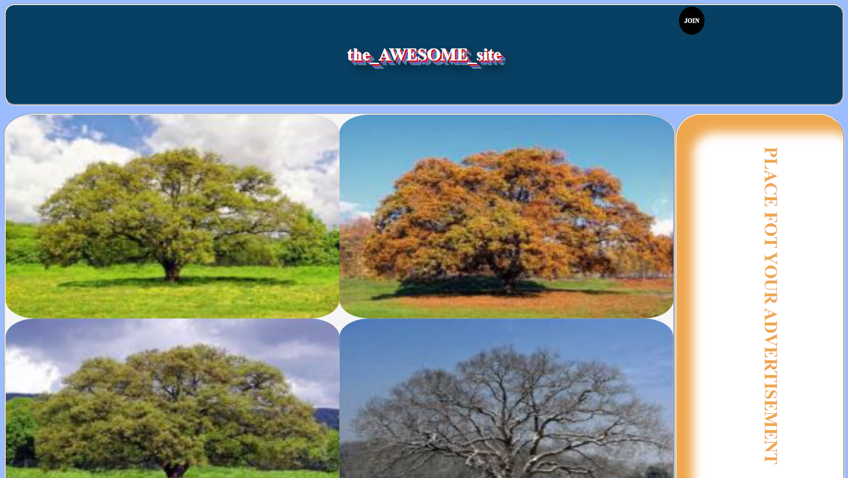
Рис. 1. Результат виконання програми

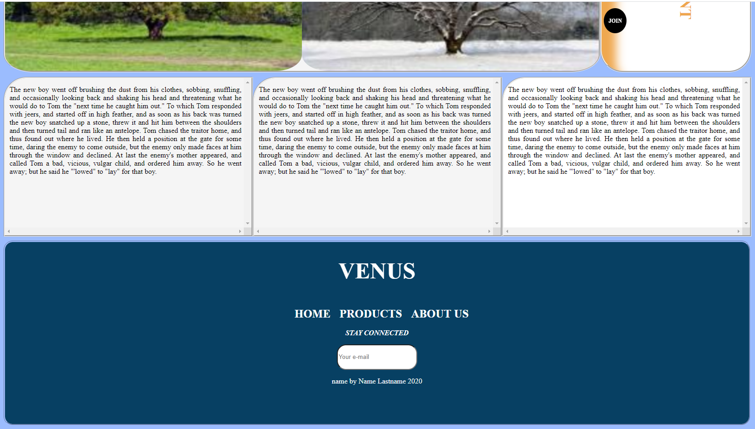
Рис. 2. Результат виконання програми

Рис. 3. Результат виконання програми
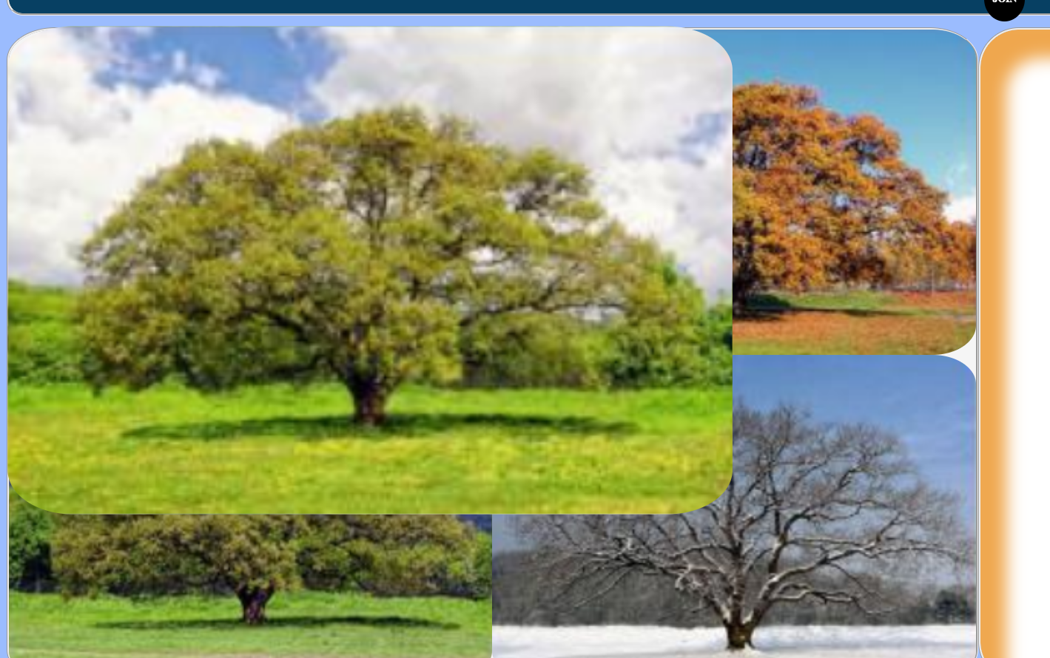
Рис. 4. Результат виконання програми
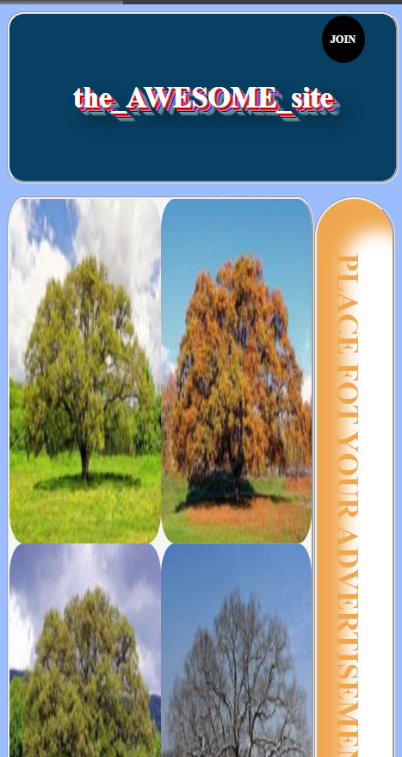
Рис. 5. Результат виконання програми
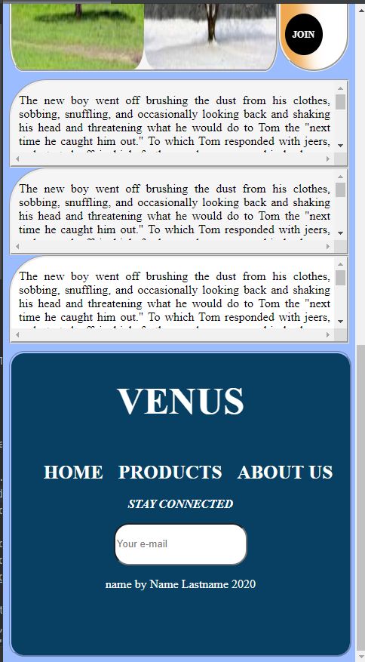
Рис. 6. Результат виконання програми

